A major breakthrough.
New minimally invasive operations often let patients go home the same day.
By Marsha Austin
Denver Post Staff Writer

Post / Glen Martin
Dr. Thomas Waliser performs a hysterectomy using a small incision and a minimally invasive technique to remove tissue. A traditional hysterectomy requires a foot-long incision and three days of hospitalization, and patients take “forever to heal,” Waliser said. The technique is not limited to gynecological patients — it has also been used for spine, heart and, most recently, orthopedic surgery.
Dr. Thomas Waliser makes a tiny, quarter-inch incision along the woman's belly button. Seconds after he pushes a plastic sheath through the cut, two TV monitors above the operating table blink to life with images of her enlarged uterus - and a massive fibroid tumor clinging to its outside wall.

Manipulating surgical tools through three more small holes in Carol Sullivan's abdomen, the surgeon and his assistant deftly detach the white, fleshy mass.
Two hours later, her uterus and at least eight tumors that over 20 years had enlarged it to the weight of an 18-week pregnancy, were gone, pulled out in pencil-thin strips.
Waliser is one of a small but growing number of Colorado surgeons who are operating in a whole new way. Using light scopes to peer deep into body cavities and tiny, camera-mounted instruments to navigate around and through organs, they practice "minimally invasive surgery," or MIS.

It's not just gynecological patients who are benefiting from this new surgical techique. In the past decade, innovations in spine, heart and, most recently, orthopedic surgery, have transformed major operations that once required week-long hospital stays and months of rehabilitation into outpatient procedures that, in some cases, allow patients to go home the same day.
"I really do believe it's going to be the standard in what patients expect," said Dr. Steven Myers, an orthopedic surgeon with Colorado Springs Orthopedic Group.
For example, a traditional hysterectomy requires a foot-long incision, three days of hospitalization and high doses of narcotics, said Waliser. Recovery generally lasts up to a month and patients take "forever to heal," he said.
Sullivan, for her part, went home within 24 hours and in much less pain than usual. She will recover far more rapidly than she would have if a surgeon had sliced open her belly, Waliser said.
Waliser is among 50 surgeons nationwide fellowship- trained in endoscopic gynecological surgery. Last year, he helped establish a minimally invasive surgery program at Centennial Medical Plaza south of Denver.
And he is recruiting top MIS surgeons from a broad array of specialties to Colorado. The goal: to educate the public about surgical alternatives that are less traumatic to the body.
"This is so new that nobody even knows that this is an option - especially the patients," Waliser said.
Sullivan said she suffered for years because she feared major surgery and wasn't aware of any less invasive option.
"I always thought I could just stick it out," she said.
It is a painfully common misconception.
Such stories are indeed more common. For four years Peggy Goss, a 49-year-old mother of two, endured excruciating abdominal pain, heavy bleeding that lasted three weeks every month, headaches and a tiredness she said she just couldn't shake.
Doctors diganosed her with a uterine fibroid. But she feared surgery because of a family history of blood clots, a condition she blames for the death of her sister during an operation. "Surgery was very scary to me," said Goss.
Encouraged by the relatively small incisions and quicker recovery time of a MIS hysterectomy, Goss said after her surgery: "It makes you wonder why more people don't do it and why I didn't do it sooner."
But MIS isn't always right for every patient, cautioned Dr. William Schlaff, University of Colorado professor of medicine and a board-certified reproductive endocrinologist.
"There are new technologies and there are new opportunities for patients to have something done through a scope," said Schlaff. "But what I tell patients is that you have to be wary."
Some MIS surgeries are technically more difficult, last longer and therefore can cause more blood loss than traditional methods. A traditional hysterectomy can be done in about an hour, Schlaff said.
Additionally, few studies have been done to compare MIS to open surgery, so patients need to ask questions about why a physician recommends MIS before agreeing to it, he said.
But for some patients, MIS can be a gentler alternative to older surgical methods, surgeons agreed.
Andrea Watkins was so frustrated after a painful tropical vacation where she hobbled on a cane, enduring a rapidly deteriorating arthritic hip, that once back in Colorado, she immediately started scouring the Internet for a hip surgeon. In addition to her arthritis, Watkins suffers from a condition that weakens her muscles - fibromyalgia - so she wasn't thrilled about major surgery.
She found Centennial orthopedic surgeon Dr. Robert Greenhow on a website.
A month after Greenhow replaced Watkins' hip, using two, 2-inch-long incisions, the 63-year-old business consultant hiked ruins in Mexico.
"I was in absolutely no pain after the surgery," Watkins said. "It doesn't feel to me like there is anything foreign in my leg."
Traditional hip replacement surgery requires a 12-inch incision along the hip and thigh, a week's hospital stay and at least three months of physical therapy, said Dr. Craig Loucks of Orthopedic Surgery Associates in Aurora. The surgery also involves cutting through the muscles and tissue connecting the pelvis to the thigh bone, a process that can leave a patient weakened.
During some of the latest minimally invasive hip-replacement procedures, surgeons use a table with moving parts to position a patient's leg and hip. They pass the diseased joint and replacement prosthesis between muscles without detaching them from the bone.
Last week, with Myers, Loucks and Greenhow replaced a patient's arthritic hip through a single, 3-inch incision, a procedure known as a "single anterior" hip replacement. The first such surgery in the Denver area, the male patient went home the next day.
Fewer than 15 U.S. surgeons have performed this procedure. In Colorado, only Myers, Loucks and Greenhow are using it, the surgeons said.
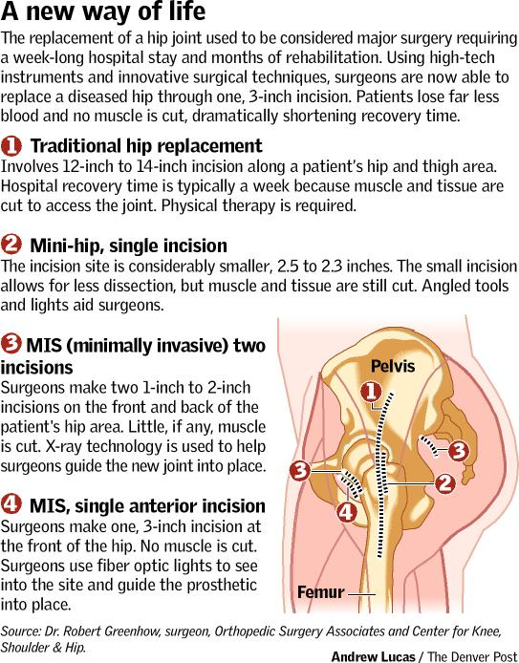
Staff writer Marsha Austin can be reached at 303 820 1242 or maustin@denverpost.com

